- CARGO OPERATIONS AND EQUIPMENT PROCEDURES

- Operating Procedure Manuals
The Company issues Operating Procedures Manuals for each type of vessel under Management. These manuals cover in general the particular procedures to be adopted in regard to cargo handling operations on each type of vessel.
Ship-specific operating procedures and checklists should be developed on board individual vessels to supplement the general Operating Procedures contained within the Company Manuals.
Reference should be made to these manuals as appropriate.
National requirements must be complied with.
- Safe Working Practices
Personnel involved in the handling of dangerous goods or liquid cargoes in bulk should refer to the ‘Code of Safe Working Practices for Merchant Seamen’. The precautions and safe practices detailed in this publication should be adhered to.
General procedures for safe working practices relevant to cargo operations as detailed in other sections of the ‘Code of Safe Working Practices’ should be followed.
- Responsibility and Care for Cargo
The Masters and Officers are responsible for all cargo carried in the vessel, which responsibility entails its correct receipt, stowage, care in carriage and discharge. The Chief Officer will be in general charge of all cargo work. He will discuss these operations with the Master and work closely with the Chief Engineer, and leave clear instructions in writing for the duty deck officer.
- Supervision When Working Cargo
A deck officer is to be on duty, either on deck or in the cargo control room, as appropriate, at all times when cargo is being worked. It is this officers’ responsibility to supervise the loading or discharging and stowage of all types of cargo and to ensure that all cargo handling and securing equipment is in good working order.
Particular attention is to be paid to the vessels stress, draught, trim, heel and stability throughout all cargo operations. Moorings are to be frequently and systematically tended to ensure undue stress is not placed on them nor do they become too slack and allow the vessel to range.
- Carriage of Dangerous Liquids in Bulk
Vessels engaged in the carriage of crude oil or petroleum products in bulk are to comply with the general requirements of the I.S.G.O.T.T. manual and the I.M.O. SOLAS Regulations, Chapter VII. Also, National requirements must be complied with.
All senior officers are required to possess appropriate dangerous cargo endorsements.
Reference should be made to the appropriate Company Operating Procedures Manual for each type of vessel for procedures, hazards and precautions involved in the operation of the above vessels.
While working in or around areas with a potential for the build-up of flammable/toxic vapours, nitrogen or inert gases, Personnel should be aware that many vapours are heavier than air, so vapours released during loading, gas freeing and accidental spills may concentrate in lower areas on deck or the engine room, especially in conditions with little or no wind. Strong winds may create low pressure on the lee side of deckhouses or other structures, and thereby cause vapour to be carried in that direction and to accumulate. Nitrogen or inert gas may also accumulate in areas with restricted ventilation. Other spaces may include forecastle spaces, the lee side of deck houses, areas with overhangs, below deck tanks and other areas with restricted access or limited ventilation.

- Carriage of Dangerous Goods in Packaged Form
The carriage of dangerous goods in packaged form on Company vessels must meet the requirements of the IMO publication ‘International Maritime Dangerous Goods Code’ (IMDG Code).
Cargo handling and transportation of these dangerous goods should be carried out by the safest means possible in order to prevent and minimise dangers to personnel, pollution of the environment and contamination of other cargoes.
Personnel involved in the handling and transport of dangerous goods should be well advised as the characteristics and hazardous properties of the goods, and of any necessary safety precautions to be observed. They should be provided with necessary protective clothing and equipment, and instructed in its use.
- Procedure for Carriage of Dangerous Goods In Packaged Form
Before accepting for shipment, the Master must be satisfied that the goods comply with all relevant regulations concerning declarations, stowage, labelling etc. the goods must also carry positive identification, as per IMDG Code. If no positive identification is available then the Master should refuse to accept the consignment for shipment until the appropriate local authority has been consulted and approval received.
In the event of a consignment being refused because it cannot be identified then the Company should be contacted and advised of the situation.
The Chief Officer should keep himself fully appraised of all developments regarding hazardous cargo, discuss handling and stowage arrangement with shore personnel, and keep the Master fully informed. In any doubtful situation the Master must be consulted.
When hazardous goods are delivered to the vessel they should be checked for correct labelling (corresponding to documentation supplied), packaging, signs of leakage/spillage or inadequate securing. Stowage and segregation arrangements are to be checked. Goods not meeting the required standards should be refused and re-landed if necessary.
Complete manifests giving all relevant details of each dangerous goods consignment should be demanded, including individual declarations and stowage plans.
If leakage, spillage or other damage is discovered after sailing then the Company and shippers are to be informed. No attempt should be made to deal with the problem until specific advice is received, except such actions as are essential to safeguard the personnel and ship, and prevent pollution of the environment. The main priority should be to ensure that no person on board is put at risk.
If any leakage or spillage occurs from a consignment not listed in the Dangerous Goods Manifest then this should be treated as for dangerous goods until otherwise identified.
- International Maritime Dangerous Goods Code
The IMDG Code is accepted as the international guide for the transport of dangerous goods and marine pollutants by sea, and is used as the basis for many national regulations.
The Code lays down basic principles for the carriage of dangerous goods and gives detailed recommendations and advice for individual substances on terminology. Packaging, labelling, stowage, segregation, handling and emergency procedures.
The Code is contained in 5 volumes including a supplement with Emergency Procedures, Medical First Aid Guide and Reporting Procedures.
- Emergency Procedures Involving Dangerous Goods
Emergencies should be dealt with in accordance with the IMO publications ‘Emergency Procedures for Ships Carrying Dangerous Goods’ (EmS) and ‘Medical First Aid Guide’ (MFAG), contained in the supplement to the IMDG Code.
The Emergency Procedures book contains measures to be followed in the case of incidents involving dangerous goods. Substances with similar emergency actions have been grouped into single emergency schedule (EmS) and these give emergency procedures for these groups.

The MFAG provides advice necessary for diagnosis and treatment of chemical poisoning within the limits of the facilities available on board ship. Minor accidents involving dangerous goods should be regarded as serious until medical advice to the contrary is obtained. Any person suffering from chemical poisoning should be seen by a doctor at the next port of call. Medical advice by radio/telephone should be sought whenever circumstances warrant, and in all cases when any doubt exists as to actions required.
In cases of chemical poisoning the Chemical Supplement to the Ship Captains Medical Guide should also be consulted.
- Availability of Information
All necessary publications (IMDG Code, ISGOTT manual, EmS, MFAG and Chem. Supplement, Tanker Safety Guide – Liquefied Gases) should be made readily available to all officers involved in the handling of dangerous goods, these officers should endeavour to familiarise themselves with the contents of the publications.
Where appropriate Emergency Procedure instructions, and contact numbers, are to be posted on the Bridge along with dangerous goods manifest and stowage plan. This information is to be kept with the stability printout for the voyage.
- Incident Reporting
All incidents involving loss, or likely loss, of marine pollutants into the sea are to be reported to the nearest coast radio or coastguard station, as per IMO standard reporting format (SMPEP) and Company’s’ procedures.
Reports should also be made whenever a harmful substance is observed at sea or whenever a ship is seen to be discharging a harmful substance.
Reference is to be made in Manuals M1, M2 and S.M.P.E.P. concerning pollution prevention and incident reporting.
- Prohibited or Restricted Cargoes
On no occasion must any cargo which is prohibited or restricted by any relevant authority be loaded without the express authority of the Company as apart from the many dangers which could be involved, to do so may invalidate the insurance cover and be in breach of the Charter and mortgage arrangements.

- Cargo Documentation
The issuing of clean Bills of Lading when cargo is known to be damaged, or is shipped in other than ‘Apparent good order and condition’, is fraudulent, and therefore on no account will a Letter of Indemnity be accepted in exchange for a clean Bill of Lading.
The Master or other Officers are to sign only cargo documents containing true and accurate statements as to the quantity and condition of the cargo. To do otherwise, without first suitably classing the document, is fraudulent.
The Master should sign ‘For the time used only’ in any Statement of Facts presented for his signature.
- Preparation of Cargo Spaces and Tanks
Each cargo space or tank is to be properly cleaned and prepared as necessary for the cargo to be loaded. Cargo space surveys and tank inspections should be made as required by charterers and/or shippers before loading commences. Records of all surveys and inspections are to be retained onboard.
- Precautions on Cessation of Cargo Work
On cessation of cargo work for any reason the Duty Deck Officer is to ensure that all precautions are taken to protect the cargo spaces.
Before sailing all cargo, cargo spaces, tanks and cargo equipment shall be properly secured for sea.
Reference should be made to the Company Operating Procedure Manuals as appropriate.

- Cargo Damage, Contamination and Discrepancy
In the event of a discrepancy between ship and shore figures in the amount of cargo loaded or discharged the Master must immediately notify the Shipper and note protest regarding the discrepancy.Any protests should be advised to Operations Department on the sailing message.
If cargo damage or contamination should occur whilst the vessel is at sea, the Master should inform Operators and Technical Department in order to contact the local P&I representative at the discharge port to attend on arrival to protect Owners interests. The Operations Department will also liaise with Charterers where necessary.
In the event of cargo damage, shortage or contamination being discovered during discharge the Master should request the local P & I representative to attend to protect owners interests and inform Manager immediately. The Company’s Insurance Incident Report Form must be completed in each case, backed up by written reports where necessary.
- Injury to Stevedores, Jetty Operators and other Shore Workers
Where accidents occurs involving injury to Stevedores, jetty operators or other shore workers an immediate investigation should be put in hand to ascertain the cause. Full and accurate entries must be made in the Log Book and statements taken from any witnesses.
These procedures are of particular importance in the United States where in addition to the above the local P & I Club representative should be called to protect Owners interests.
- Annual and Periodical Examination of Lifting Plant
All lifting plant and associated loose gear of the lifting and rigging equipments must be subjected to a thorough examination by a competent person at intervals not exceeding twelve months. A thorough examination means a detailed examination supplemented by such dismantling as considered necessary for access to or removal of hidden parts for Examination. Presently the flag administrations of our vessels do not allow ships staff to conduct these inspections and a request to the Fleet needs to be made in good time to arrange a surveyor to attend for these examinations. If as a result of this examination any defective equipment is found such equipment is not to be used until repaired, tested and a certificate issued by a competent authority undertaking such test.
Such annual examinations of lifting equipments and loose gears should be inspected and certified, recorded and stamped by the vessel’ class society in the ship’s Register of Lifting Appliances & Loose Cargo gear. The maintenance of the required certification in accordance with the Flag Administration rules. Additionally the requirement is to retain certificates for each fall wire and topping lift wires. The retirement criteria of wires and rigging equipments on board max 5 years if physically found fit for purpose at the periodically on baord visual inspections. On board inspections should be included ;
- Retention of certificates or equivalent for each item of lifting or rigging equipment, including fall wires
- The inspection of each item of equipment by a competent person at a defined interval according to Plan and maintenance systems.
- The marking of each item of equipment with a unique identifier.
- The marking of each item of equipment with its SWL.
- The marking of each item of equipment with a ready means to identify that the equipment remains fit for continued use.
Although the Regulations allow for a maximum period of five years between testing of lifting plant some administrations still adhere to four year intervals. It is therefore the Company's policy to comply always with vessel’s Flag Administration requirements. The five yearly Surveys and Testing are to be carried out by a competent authority e.g. Classification Society who are authorised to issue certificates in respect of such surveys and test.
All lifting plant onboard must be covered by valid test certificates.
Lifting plant under these regulations includes derricks and their associated rigging, hook, etc., stores cranes etc. and their associated equipment: any gear by means of which a lead can be attached to a lifting appliance and which does not form an integral part of that appliance or load e.g. slings, straps, chains, drum lifters etc. It also includes engine room cranes, hoists, chain blocks and other lifting devices.
- Maintenance and Examination Standards for Cargo Gear and Lifting Equipment
All lifting equipment is to be maintained in good working order and routinely inspected on a regular basis on board inspection by a competent person. All cargo securing equipment, winches, chains, slings, trestles, twist locks and other equipment and devices used in cargo operations should similarly be maintained in good condition and inspected before use, and at regular intervals. See also Engineering Manual Section 3.12

- LIFTING PLANT
- Introduction
Based on the findings of the risk assessment, appropriate control measures should be put into place to protect those who may be affected. This chapter highlights some areas which may require attention in respect of lifting plant
- General Requirements
1. Lifting appliances should be;
a. securely anchored, or
b. adequately balanced or counterbalanced, or
c. supported by outriggers,
as necessary to ensure their stability when lifting.
2. If counterbalance weights are moveable, effective precautions should be taken to ensure that the lifting appliances is not used for lifting in an unstable condition. In particular all weights should be correctly installed and positioned.
3. The operator should check safety devices fitted to lifting appliances before work starts and at regular intervals thereafter to ensure that they are working properly.

- Controls

Controls of lifting appliances should be permanently and legibly marked with their function and their operating directions shown by arrows or other simple means, indicating the position or direction of movement for hoisting or lowering, slewing or luffing, etc.
Make-shift extentions should not be fitted to controls nor any unauthorised alterations made to them. Foot-operated controls should have slip-resistant surfaces.
No lifting device shuld be used with any locking pawl, safety attachment or device rendered inoperative. If, exceptionally, limit switches need to be isolated in order to lower a crane to its stowage position, the utmost care should be taken to ensure the operatin is completed safely.

- Lifting Operation

Every lifting operation must be subject to risk assessment, lifting permit (company SMS form SF 49), properly planned, appropriately supervised, and carried out in a safe manner.
A powered appliances should always have a person at the controls while it is in operation; it should never be left to run with a control secured in the ON position.

If any powered appliances is to be left unattended with the power on, loads should be taken off and controls put in ‘neutral’ or ‘off’ positions. Where practical, controls should be locked or otherwise inactivated to prevent accidental restarting. When work is completed, power should be shut off.

The person operating any lifting appliances should have no other duties which might interfere with their primary task. They should be in a proper and protected position, facing controls and, so far is practicable, with a clear view of the whole operation.
Consideration should be given to the effects of weather conditions on all lifting operations, whether inside the ship or outside on deck, and such operations should be suspended before conditions deteriorate to the extent that lifting becomes dangerous.
Where the operator of the lifting appliances does not have a clear view of the whole of the path of travel of any load carried by that appliances, appropriate precautions should be taken to prevent danger. Generally this requirement should be met by the employement of a competent and properly trained signaller designated to give instructions to the operator. A signaller includes any person who gives directional instructions to an operator while they are moving a load, whether by manual signals, by radio ot otherwise.

The signaller should have a clear view of the path of travel of the load where the operator of the lifting appliances cannot see it.
Where necessary, additional signallers should be employed to give instructions to the first signaller.
Every signaller should be in a position that is; safe, and in plain view of the person to whom they are signalling unless an effective system of radio or other contact is in use with involved crew or barge etc.

All signallers should be instructed in and should follow a clear code of signals, agreed in advance and understood by all concerned in the operation.

- Use of Lifting Equipment

1. Loads should if possible not be lifted over a person or any access way, and personnel should avoid passing under a load which is being lifted. Loads should not be lifted over any access way.

2. No person should be lifted by lifting plant except where the plant has been designated or especially adapted and equipped for the purpose or for rescue or in similar emergencies.

3. All loads should be properly slung and properly attached to lifting gear, and all gear properly attached to appliances.

4. The use of lifting appliances to drag heavy loads with the fall at an angle to the vertical is inadvisable because of the friction and other factors involved and should only take place in exceptional circumstances where the angle is small, thereis ample margin between the loads handled and the safe working load of the appliance, and particular care is taken. In all other cases winches should be used instead. Derricks should never be used in union purchase for such work.
5. Lifting appliances should not be used in a manner likely to subject them to excessive over-turning moments.

6. Ropes, chains and slings should not be knotted.

7. Lifting gear should not be passed around edges liable to cause damage without appropriate packing.

8. Where a particular type of load is normally lifted by special gear, such as plate clamps, other arrangements should only be substituted if they are equally safe.

9. Wire ropes should be regularly inspected and treated with suitable lubricants. These should be thoroughly applied so as to prevent internal corrosion as well as corrosion on the outside. The ropes should never be allowed to dry out.

10.Lifting operations should be stopped if wind conditions make it unsafe to continue them.

11.Cargo handling equipment that is lifted onto or off ships by crane or derricks should be provided with suitable points for the attachment of lifting gear, so designed as to be safe in use. The equipment should also be marked with its own weight and safe working load.

12.Before any attempt is made to free equipment that has become jammed under load, every effort should first be made to take off the load safely. Precautions should be taken to guard against sudden or unexpected freeing. Others not directly engaged in the operation should keep in safe or protected positions.

13.When machinery and, in particular, pistons are to be lifted by means of screw-in eye bolts, the eye bolts should be checked to ensure thatb they have collars, that the threads are in good condition and that the bolts are screwed hard down on to their collars. Screw holds for lifting bolts in pistonheads should be cleaned and the threats checked to see that they are not wasted before the bolts are inserted.

14. Any lifts by two or more appliances simultaneously can create hazardous situations and should only be carried out when unavoidable.

- Safe Working Load (SWL)

1. A load greater than the safe working load should not be lifted unless;
a. a test is required by regulation; and
b. the weight of the load is known and is the appropriate proof load; and
c. the lift is a straight lift by a single appliance; and
d. the lift supervised by the competent person who would normally supervise a test and carry out a through inspection; and
e. the competent person specifies in writing that the kift is appropriate in weight and other respects to act as atest of the plant, and agrees to the detailed plan of the lift; and
f. no person is exposed to danger thereby.

1. Any grab fitted to a lifting appliance should be of an appropriate size, taking into account the safe working load of the appliance, the additional stresses on the appliance likely to result from the operation, and the material being lifted.

2. SWL marking of the equipment (hook, schakles etc.) should be visible at all times. No any means other than original marking such as PVC marking etc are accepted.

- Use of Cranes
Ships’ cranes should be properly operated and maintained in accordance with manufacturers’ instructions. Companies, employers and masters, as appropriate, should ensure that sufficient technical information is available including the following information;
length, size and safe working load of falls and topping lifts.
Safe working load of all fittings.
Boom limting angles.
Manufacturers’ instructions for replacing wires, topping up hydraulics and other maintenance as appropriate.
Access to a crane should be always by the proper means provided. Cranes should be stationary while accessing.
Personnel transfer via crane is not allowed in case of the vessel has no approved crane and basket on board for this operation.
Where a single hose crane fitted Hydraulic hoses (at least one hydraulic hose of each size should be available on board)

And below spare parts may to be considered to carried on board;

- Complete winch motors or a comprehensive set of manufacturers recommended spare parts.
- Complete hydraulic pumps or a comprehensive set of manufacturers recommended spare parts.
- Lifting and luffing wires as appropriate to the design of the crane.

- Overhaul of Cargo Gears
When a cargo block or shackle is replaced, care should be taken to ensure that the replacement is of the correct type, size and safe working load necessary for its intended use.
All shackles should have their pins effectively secured or sized with wire.
A special check should be made on completion of the work to ensure that all the split pins in blocks etc. have been replaced and secured.
On completion of the gear overhaul, all working places should be cleaned of oil or grease.
All shipboard lifting equipment, such as is used for the handling of cargo transfer equipment and/or gangways, should be examined at intervals not exceeding one year and load tested at least 5 years unless local, national or company regulations require more frequent examinations.

Lifting equipment includes:
Cargo hose handling cranes, derricks, davits and gantries.
Gangways and associated cranes and davits.
Store cranes and davits.
Chain blocks, hand winches and similar mechanical devices.
Personnel lifts and hoists.
Strops, slings, chains and other ancillary equipment.
All equipment should be tested by suitably qualified individuals or authorities and be clearly marked with its Safe Working Load (SWL), serial number and test date.

The ship should ensure that all maintenance of lifting equipment is carried out in accordance with manufacturer’s guidelines. Routine checks should be included within the ship’s planned maintenance system.

All records of tests and inspections should be recorded in the ship’s Lifting Equipment Register. There records should be available for inspection by Terminal Representatives when their personnel are involved in lifting operations using ship’s equipment.

- Training
Lifting equipment should only be operated by personnel who are trained and proven to be competent in its operation.

5.6.10 Elevator maintenance

Elevator maintenance on board is subject to risk assessment, performing elevator maintenance permit SF 50 and tool box meeting prior to commence the work. The elevator maintenance should be carried in accordance with manufacturer’s recommendations.

- GUIDANCE FOR MANUAL HANDLING

5.7.1 Introduction
This chapter identifies some areas that may require attention in respect of manual handling. In all cases, a risk assessment should be used as the basis for appropriate control measures, which should be put in place to protect those who may be affected.

The assessment should take full account not only of the characteristics of the load and the physical effort required but also of the working environment (e.g. ship movement, confined space, high or low temperature, physical obstacles such as steps or gangways) and any other relevant factors (e.g. the age and health of the person, the frequency and duration of the work).

5.7.2 General
The term ‘manual handling’ is used to describe any operation that includes any transporting or supporting of a load, lifting, putting down, pushing, pulling, carrying or moving by hand or bodily force. This guidance is generally concerned with preventing musculoskeletal injury.

There may, of course, be other hazards to those handling loads (e.g. from leakage of a hazardous substance from a package that is being moved) but these are dealt with in other relevant chapters.

Musculoskeletal injuries can occur as a result of accident, poor organisation or an unsatisfactory working method.

5.7.3 Safety

Assess the risk of injury from any hazardous manual-handling activity.
Avoid the need for any hazardous manual-handling operations, which may cause injury to seafarers, e.g. by re-organisation of the work, or automating or mechanising the operation.
Reduce the risk of injury from hazardous manual handling.
Provide information on the weight of each load and, if appropriate, which side is heaviest.
Train seafarers in appropriate manual-handling techniques. Before instructing personnel to lift or carry by hand, where there is a risk of injury, Companies should consider whether alternative means of doing the same job would reduce this risk.

Means of reducing the risk of injury may include:
- re-organisation of the workplace (to enable seafarers to maintain good posture while lifting or carrying); and
- taking account of an individual’s capabilities when allocating tasks.

There are often limitations in a ship on the improvements that can be made but the Company should ensure that, as far as reasonably practicable, risks have been minimised.

Instruction for personnel should involve experienced and properly trained seafarers demonstrating best practice, especially to new recruits.

Advice to seafarers

You should make full and proper use of any system of work provided by the Company.

You should:

- use any mechanical aids provided;
- follow appropriate systems of work laid down for your health and safety;
- take sensible precautions to ensure that you are aware of any risk of injury from a load before picking it up;
- cooperate on all health and safety matters;
- inform your line manager if you identify hazardous handling activities;
- plan the lift – where is the load to be placed?
- consider whether you need any help with the load. Some loads require two or more people to lift safely.
Are there appropriate handling aids you could use? For a long lift, such as deck to shoulder height, consider resting the load midway in order to change grip;

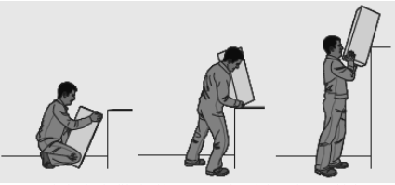

- assess the load to be lifted, taking account of any information provided;
- look for sharp edges, protruding nails or splinters, surfaces that are greasy or otherwise difficult to grip and for any other features that may prove awkward or dangerous, e.g. sacks of ship’s stores may be difficult to get off the deck;
- ensure that the deck or area over which the load is to be moved is free from obstructions, especially in narrow accesses, and is not slippery; and
- check the final stowage location to ensure that it is clear and suitable for the load.

5.7.4 Good manual-handing techniques
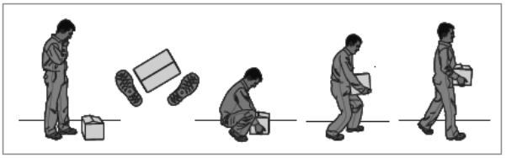

The diagram illustrates some important points in lifting techniques:

The load and the lift should be assessed before lifting.
- A firm, stable and balanced stance should be taken, close to the load with the feet apart but not too wide, with one leg slightly forward to maintain balance, so that the lift is as straight as possible.
- At the start of the lift and when lifting from a low level or deck, a crouching position should be adopted, with knees and hips bent, whilst maintaining the natural curve of the back to ensure that the legs do the work. It helps to tuck in the chin while gripping the load and then raise the chin as the lift begins.
- The load should be gripped with the whole of the hand, not fingers only. If there is insufficient room under a heavy load to do this, a piece of wood should be put underneath first. A hook grip is less tiring than keeping the fingers straight. If the grip needs to be varied as the lift proceeds, this should be done as smoothly as possible.
- The load should be lifted by straightening the legs, keeping it close to the body. The heaviest side should be kept closest to the trunk. The shoulders should be kept level and facing the same direction as the hips. Turning by moving the feet is better than twisting and lifting at the same time. Look ahead, not down at the load, once it is held securely.

When two or more people are handling a load, it is preferable that they should be of similar stature. The actions of lifting, lowering and carrying should, as far as possible, be carried out in unison to prevent strain and any tendency for either person to overbalance.

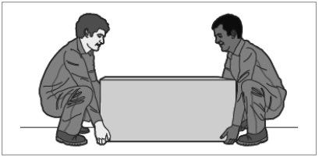

The procedure for putting a load down is the reverse of that for lifting: the legs should do the work of lowering with knees bent, back straight and the load close to the body. Care should be taken not to trap fingers. The load should not be put down in a position where it is unstable. If precise positioning is necessary, the load should be put down first and then slid into the desired position.

A load should always be carried in such a way that it does not obscure vision, so allowing any obstruction to be seen.

The risk of injury may be reduced if lifting can be replaced by controlled pushing or pulling. For example, it may be possible to slide the load or roll it along. However, uncontrolled sliding or rolling, particularly of large or heavy loads, may introduce fresh risks of injury. Particular care must be taken if:
- stooping, stretching or twisting is likely;
- hands on the load are not between waist and shoulder height;
- the deck area is insecure or slippery;
- force is applied at an angle to the body;
- the load makes sudden or unexpected movements; and
- if the vessel is rolling or pitching.

For pulling and pushing, a secure footing should be ensured, and hands applied to the load at a height between waist and shoulder wherever possible. Wheels on barrows and trolleys should run smoothly, and the supervisor or safety officer should be informed if the equipment provided is not suitable, or is in poor condition

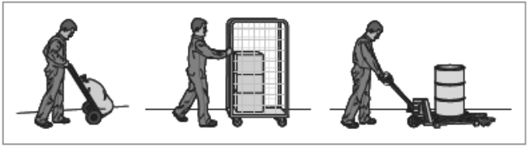

A further option, where other safety considerations allow, is to push with the worker’s back against the load, using the strong leg muscles to exert the force.

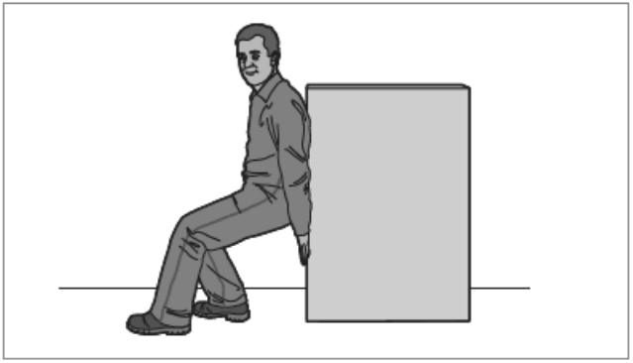

Even a gentle uphill slope dramatically increases the force needed to push an object, so help may be necessary when moving a load up a slope or ramp. Care should be taken with unbraked trolleys and sack trucks on a moving/rolling deck, because sudden changes in the angle of deck and direction of the slope may result in loss of control and injury. If a trolley becomes loose, do not try to stop it by standing in its way, but get behind it and try to act as a brake.

Care must be taken with the laying out of heavy mooring ropes and wire ropes/hawsers. This duty requires a good technique initially in lifting the heavy eye of the rope, followed by a good pulling technique. Crews should make sure that there are enough people available to do the task safely.

When moving a load, such as a barrel or drum, rolling the load may be a safer operation than lifting it. Care must still be taken, and the use of a trolley should be considered for heavy or large barrels or drums.

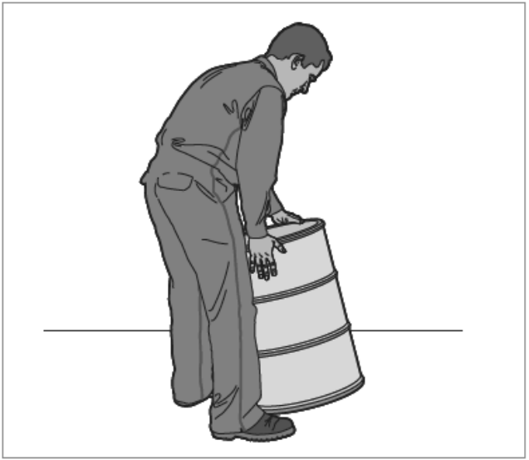

Suitable shoes or boots should be worn for the job. Protective toecaps help to guard toes from crushing if the load slips

Clothing that does not catch in the load and gives some body protection should be worn.

Where the work is very strenuous (e.g. due to load weight, repetitive effort over a period or environmental factors, such as a confined space or an extreme of temperature), rest should be taken at suitable intervals to allow muscles, heart and lungs to recover. Fatigue makes accidents more likely on work of this type.

Whenever possible, manual lifting and carrying should be organised in such a way that each person has some control over their own rate of work

Crew should consider to take steel plates on the front and secured one by one to separate on area/location or securing steel plates by other means of securing arrangement. Handling of heavy steel plates are detailed with company safety procedures. Also, the vessel made an additional leaning barrier in front of the steel plate thus they could be leaned on them to take any plate from inside.

Environmental factors should be taking account while manual handling
- Steep slopes and rough surfaces can increase the amount of force required to push/pull a load.
- Environmental factors such as temperature, lighting and air currents can increase the risks of pushing/pulling.
- Floor surfaces that are clean and dry can help reduce the force needed to move a load.
- Lack of space can force the worker to adopt awkward postures.
- Handling in confined spaces and narrow passages/doorways could cause a trapping/abrasion injury.
- Swells or seas effects such pitching and/or rolling which causes loss of balance and put more while handling heavy object.
- Swells or seas effects could also cause the movement of load, heavy object such as metal sheets or pipe while they are properly secured/protected at store position or while they are handling by someone.

